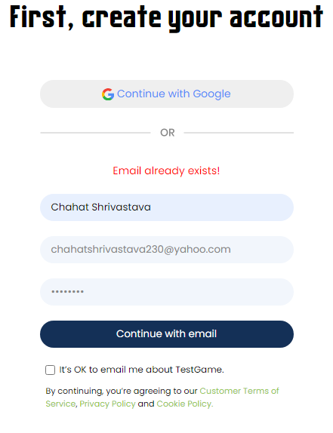

I accept to receive the emails from TestGame.

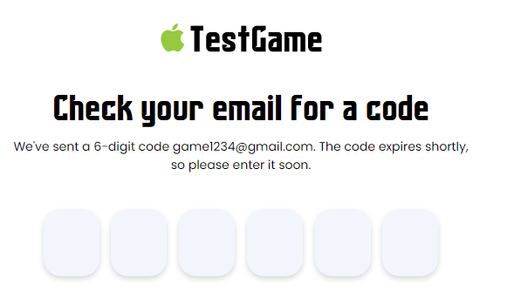

**The code is sent to the mail entered. Please check it!**

We’ve sent you a 6 digit code from [gaming.gameappstudio@gmail.com](mailto:gaming.gameappstudio@gmail.com).Enter the code soon as it is valid only for 2 minutes.

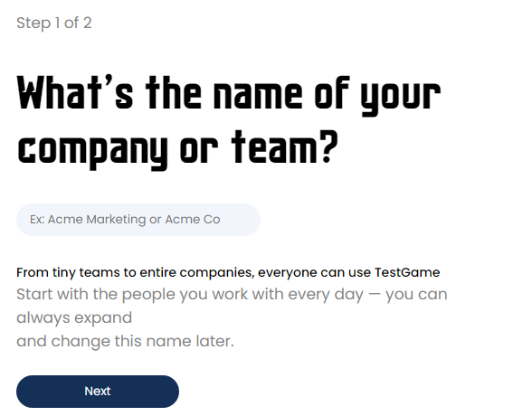

**Please enter the name of the Team/Company that you are associated with!**

TestGame is available for both small and big organizations. Start playing with your colleagues.

This name can be changed later.

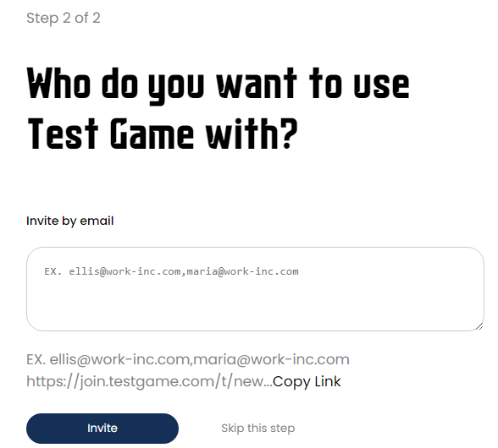

**Invite the game players.**

Send an E-mail invitation to the players.

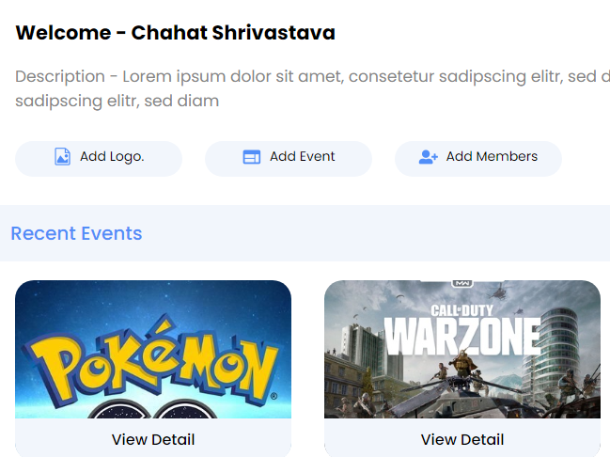

**Welcome – Chahat Shrivastava**

Enter the free events and get a new hyper-casual game experience!

Start playing the game events with your colleagues, friends, and families. This is the best refreshment and recreational activity to be carried out in any work-meeting or other gatherings with minimal items required. This easy to play TestGame provides exciting features and rewards and helps relieve stress with optimum time utilization. This hyper-casual experience is a tap to play and a tap to win a fascinating feature.

Tap with varying frequencies and strategies to help your team win!

By downloading the game, you agree to our terms and conditions for the service provided.

We hope that you are having a great experience with TestGame. Your satisfaction is our sole responsibility. We hope this unique experience enhances your hyper-casual world’s fascination. We are working forward to get more exciting features at your doorsteps.

Are you still un-enrolled? This is the perfect landing for stress bursting and fun!

Your valuable suggestions are assets for us. Contact us for feedback and suggestions.

Start the Game…TAP and WIN!